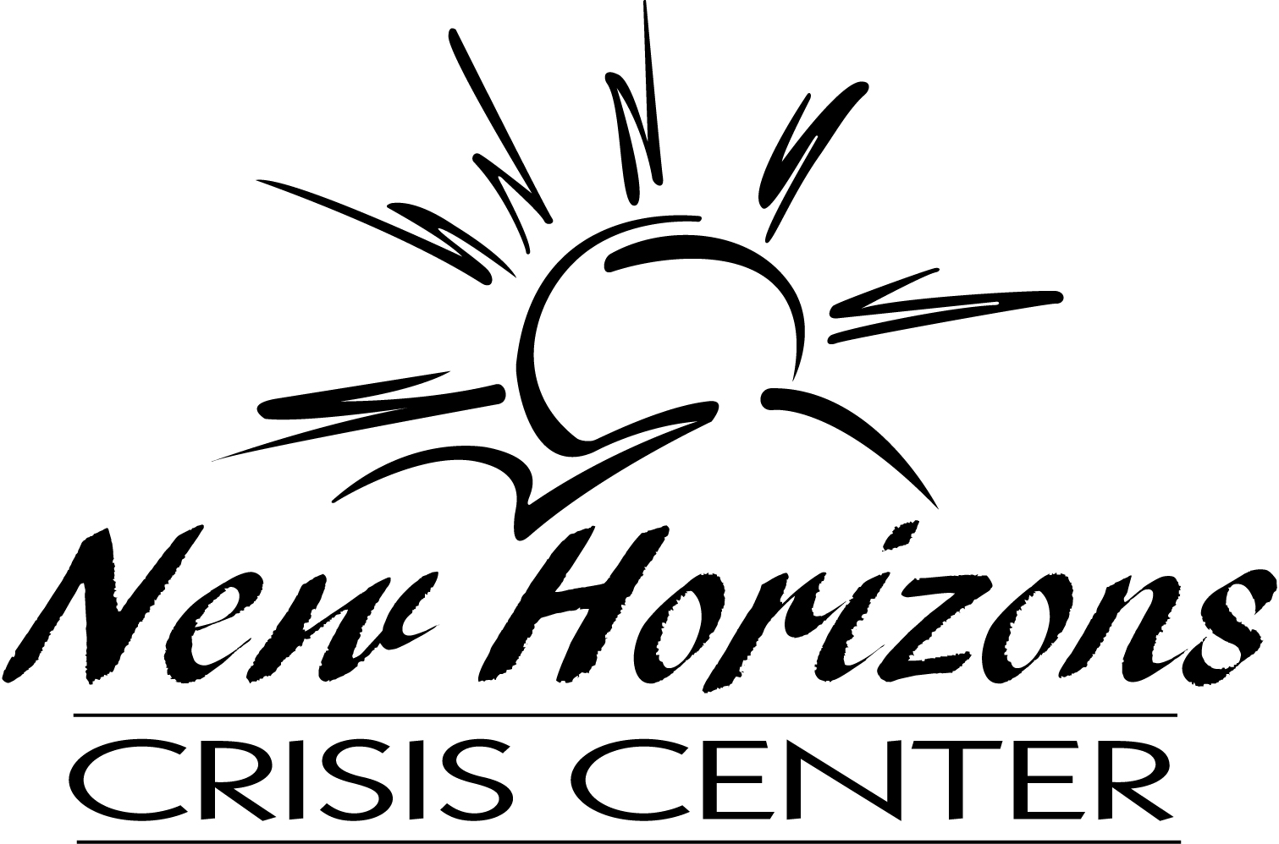
Serving crime victims in Lincoln, Lyon, Murray, and Redwood Counties of Southwest Minnesota since 1981.
Client Feedback Survey

Our agency continually evaluates our services to help us serve our current and future clients better. We believe that a good way to measure effectiveness is by asking for client feedback. Please be honest as you complete this form. We value your input. This is a confidential survey, so there is no need to identify yourself. How you respond will not affect your relationship with your advocate or this agency.

If there are questions you prefer not to answer, leave them blank. When you have completed the survey, fold it in half and tape it closed. Please place the survey in the survey box located at the front of the New Horizons Crisis Center (NHCC) office or drop the survey in the mail. Ask an advocate for postage if you choose to mail your survey. Thank you for completing this form.

1) Would you like to provide the name of the advocate who assisted you? (You are not required to do so.)
Yes No Unknown If yes, Advocate’s Name:

2) The advocate informed me of applicable agency services and programs.
Yes No

3) I learned new information about how to keep myself (or my family) safe.
Yes No

4) The advocate treated me with dignity and respect and spoke in a way that I understood.
Strongly Disagree Disagree Neutral Agree Strongly Agree Not Applicable

5) The advocate gave options so that I could make my own decisions about what works best for me.
Strongly Disagree Disagree Neutral Agree Strongly Agree Not Applicable

6) The advocate provided helpful information both verbally and in writing.
Strongly Disagree Disagree Neutral Agree Strongly Agree Not Applicable

7) The advocate made referrals to other appropriate agencies and connected me with resources.
Strongly Disagree Disagree Neutral Agree Strongly Agree Not Applicable

8) I would use NHCC services again if I needed to and/or I would recommend NHCC to someone else.
Strongly Disagree Disagree Neutral Agree Strongly Agree Not Applicable

9) What did you find most helpful about the advocate and/or agency?

10) How would you improve the services that you received?
11) Anything else you want us to know?

We value your feedback. Thank You.
New Horizons Crisis Center

New Horizons Crisis Center
Please ask a staff member for adequate postage.
109 South 5th Street, Suite 40
Marshall, MN 56258

NEW HORIZONS CRISIS CENTER
Attn: Crime Victim Services Feedback Form
109 South 5th Street, Suite 40
Marshall, MN 56258
